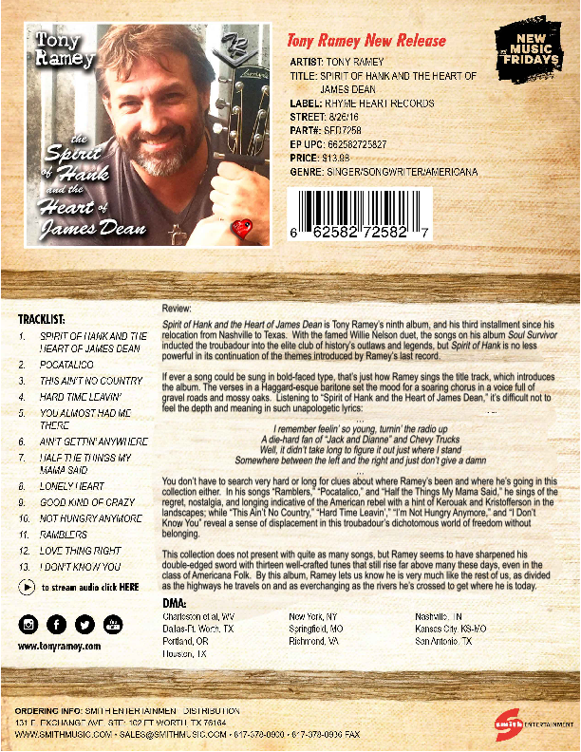
Tony Ramey Biography

Tony Ramey grew up in West Virginia on Bluegrass and Bill Withers; found Willie, Waylon, Cash, and Kristofferson at eleven, who compelled him to write songs; then heard Steve Earle who made him move to Guitar Town to hone his craft; and he left for Texas when the road called him out again...
Somewhere in the middle of all that he acquired a Masters, taught at a university while working on his PhD, and garnered Gold and Platinum Records as a songwriter in Nashville. Currently he tours the US and Texas, where he has been named 2016's Independent Artist of the Year by the Texas Country Music Association.
With the exception of his release Soul Survivor, featuring a duet with the iconic Willie Nelson (also a new fan of his music), Tony Ramey has not caught much press. Yet, he is still grabbing the attention of industry people, and growing his audience by leaps and bounds because of his undeniable prowess as a singer/songwriter, and his passion for playing live. Ramey has spent most of his music career flying below the media radar, refusing to don make-up and perform the dog and pony show for the camera. Not a fan of glitz and glamour, Tony prefers the troubadour life-style, and the solace of his writer's getaway between shows where he says he can "be alone with nature, his thoughts, and the eternal spring of the Art Spirit."
It's not uncommon for artists of Ramey's ilk to find a low profile as a result of an obsessive pursuit of the next song, next town, next project, or the next artistic endeavor, forsaking photo ops and publicity driven functions…So following the bohemian path that most true artists naturally follow, Tony occupies an awkward middle ground in terms of his recognition. His name rings a bell outside his touring routes because he is a giant in terms of his craft. Most listeners understand the power of his gift only upon experiencing it first hand--at a show or by hearing one of his records. Industry icons like Willie Nelson and George Strait know his name well because of his status as a poet in the purest sense of the word.
Ramey admits that his current project Spirit of Hank and the Heart of James Dean came at a strange time. He says of contemporary music and the state of the industry, "We live in an age when the album is obsolete, the song is incidental to the artist's brand, and artists seem only as popular as their pockets are deep. But I still make music the way I want to make it. There are awesome opportunities out there for Indie's these days--Kickstarter, crowd funding, Indy Labels, etc.--so all is not lost in big business; we just have to work a little harder for a little less. Nobody told me this life would be easy, and I don't mind the sweat." With songs like "The Spirit of Hank and the Heart of James Dean," “This Ain’t No Country,” ”Ramblers,” "Pocatalico," "Almost Had Me There," “Ain’t Gettin’ Anywhere," "Lonely Heart," and "Good Kinda Crazy," Ramey’s next album is chalk full of powerhouse songs that will continue to turn heads and wow audiences everywhere.

TRME Management Group

CONTACT INFORMATION

Renegade Media Group
Joel Johnson, Agent of Record
105 West Stegall
Robinson, Texas 76706
wacopatriot@gmail.com
booking@tonyramey.com
254.733.6757

Publishing and Record Company email:
RhymeHeart@tonyramey.com

Music Access Sites and Tony Ramey Affiliated Links:
http://www.TonyRamey.com
http://www.songtradr.com/TonyRamey
http://www.facebook.com/TonyRameyPage
http://www.instagram.com/TonyRameyMusic
http://www.Twitter.com/TonyRamey
http://www.youtube.com/TonyRameyMusic
http://www.ReverbNation.com/TonyRamey
http://www.SoundCloud.com/TonyRamey

- Broadcast Music Incorporate Award Winning Songwriter
- CMA of Texas Independent Artist of the Year 2016
- CMA of Texas New Song of the Year 2018
- Texas CMA Country Gospel Songwriter of the Year

AWARDS AND ACCOLADES

